Managing third party claims | MSP-08
Maintenance System Procedure | MSP-08
This procedure explains how to document, review and action third party claims.
Road users make claims against the TfNSW when they believe that the condition of TfNSW’s asset has led or contributed to damage to their property (damage to windscreens, tyres, suspension, etc.). The Claims Services section of Business Services Group handles such claims and may call on Council to provide evidence that confirms or refutes the claims.
Information relevant to a claim is available from Reflect. This includes the road condition, recent inspections, defects identified, accident history and accomplishment-to-date relevant to the location and time of an incident.
Process
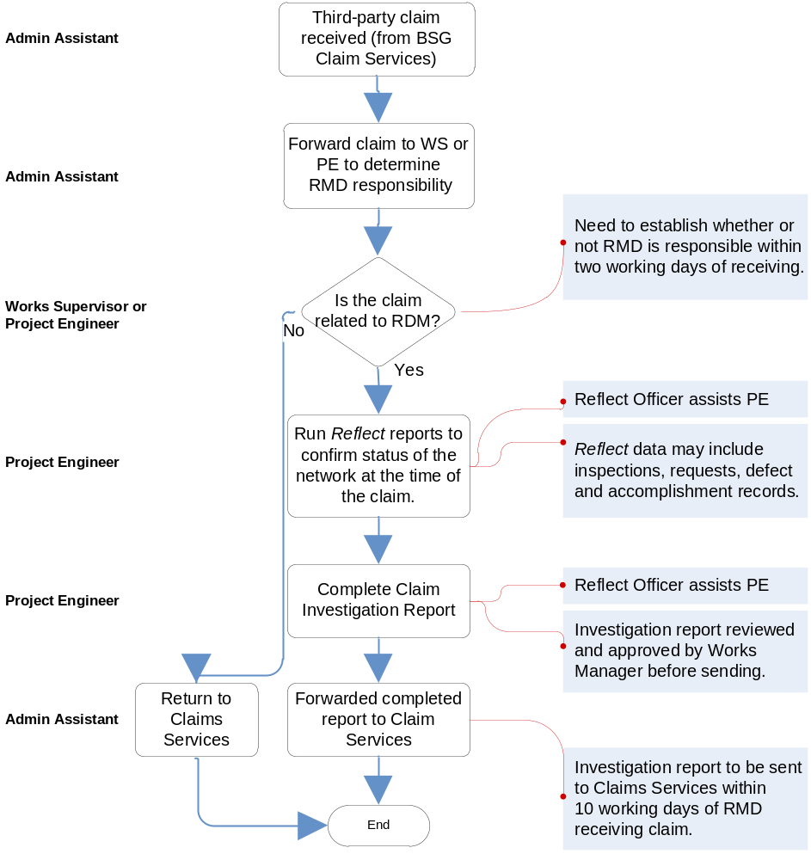
TfNSW

TfNSW

TfNSW Works Supervisor or Project Coordinator

Council Reflect Officer

TfNSW Project Coordinator

TfNSW

Reflect Officer assists TfNSW Coordinator
Forward claim to WS or PE to determine TfNSW responsibility
Investigation report to be sent to Claims Services within 10 working days of TfNSW receiving claim.

TfNSW?

